Create Tables in mysql:
Create table for Hospitals:
Screenshots of OpenStack below:

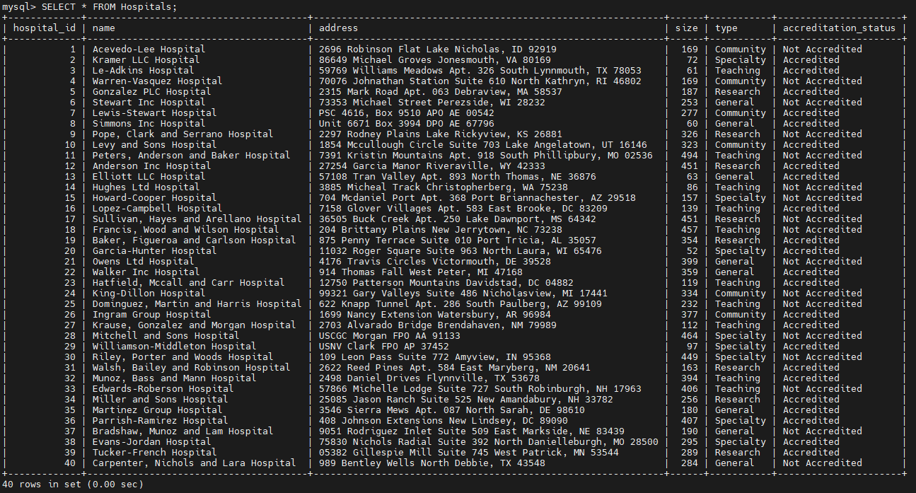
Create table for Doctors:
Screenshots of OpenStack below:
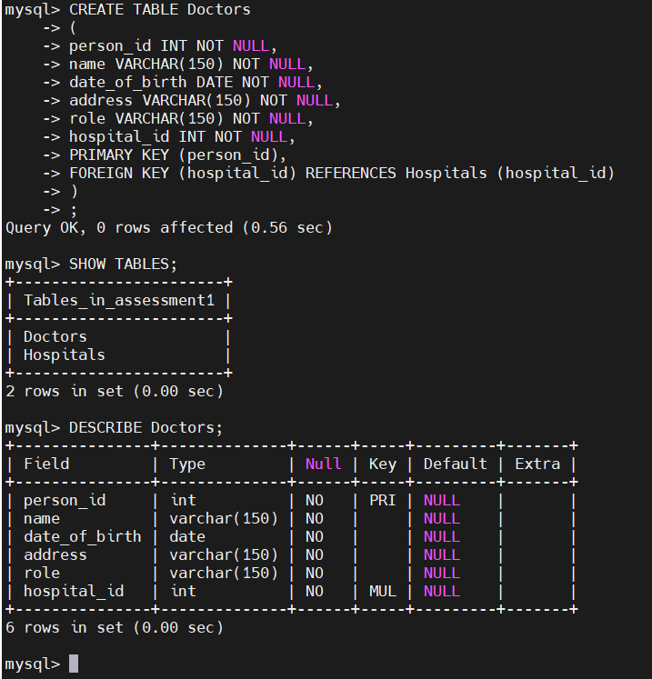
Not all data present in table shown below screenshot:
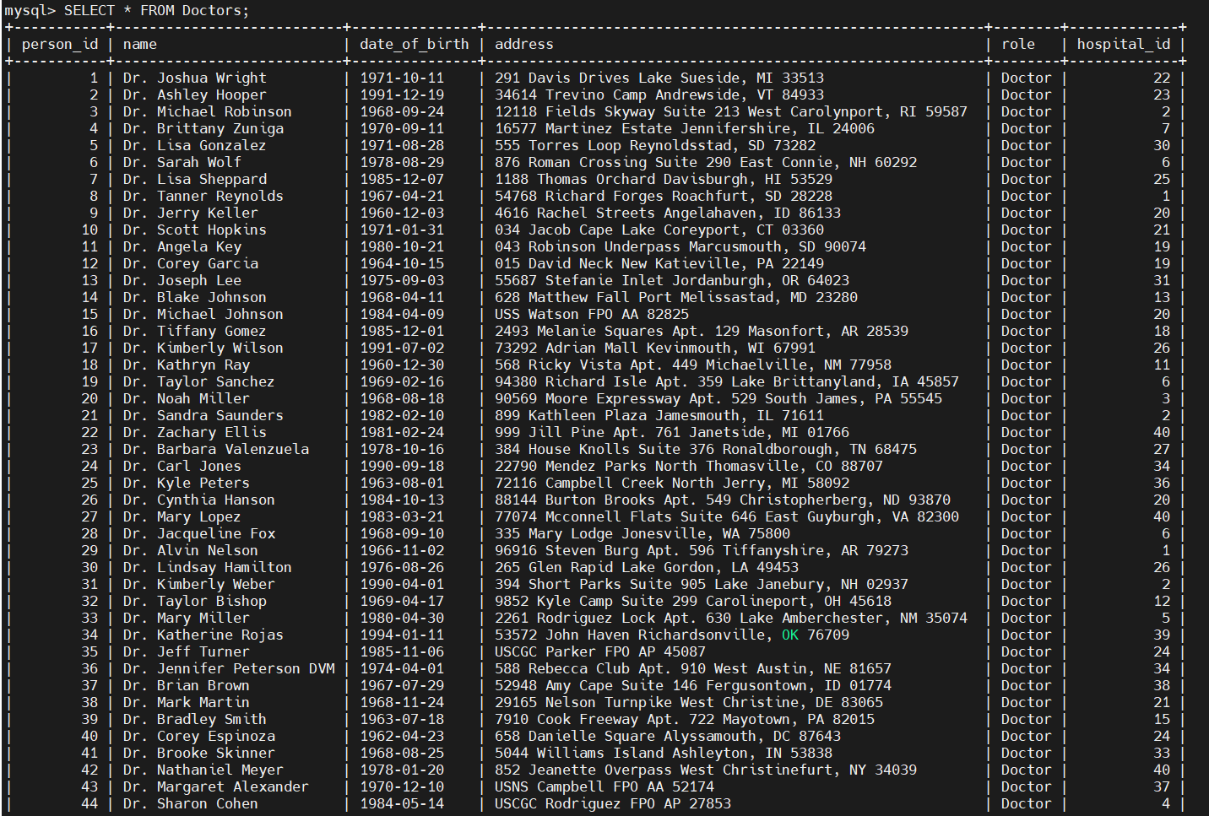

Create table for Patients:
Screenshots of OpenStack below:
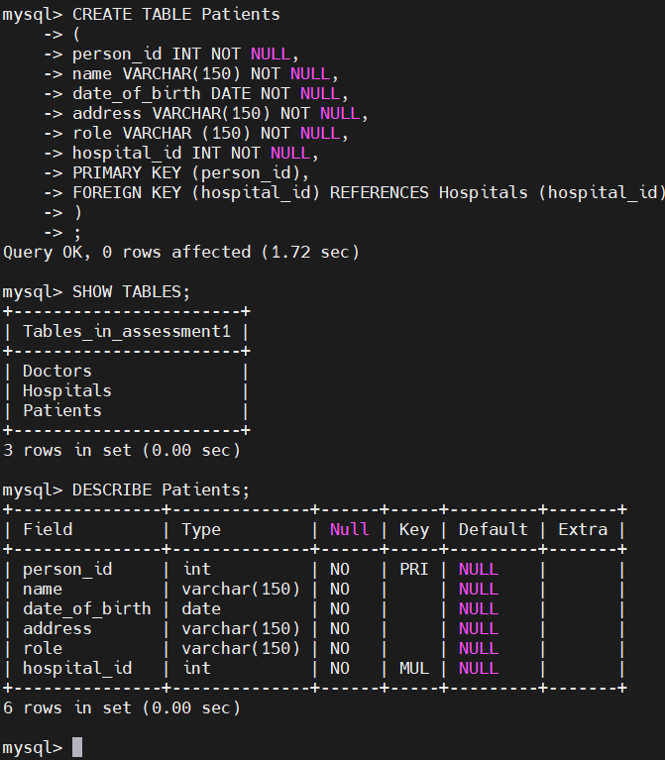
Not all data present in table shown below screenshot:
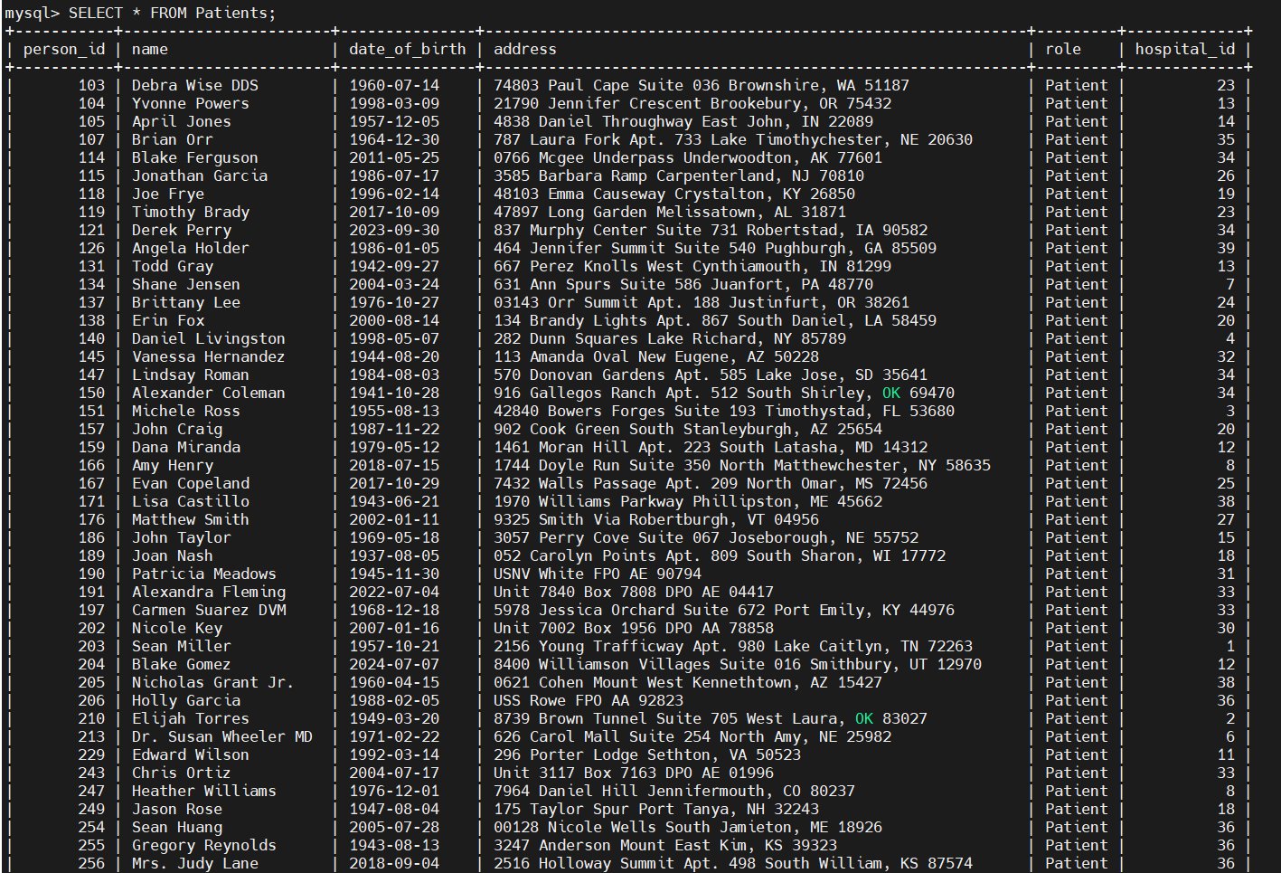
Create table for Prescriptions:
Screenshots of OpenStack below:
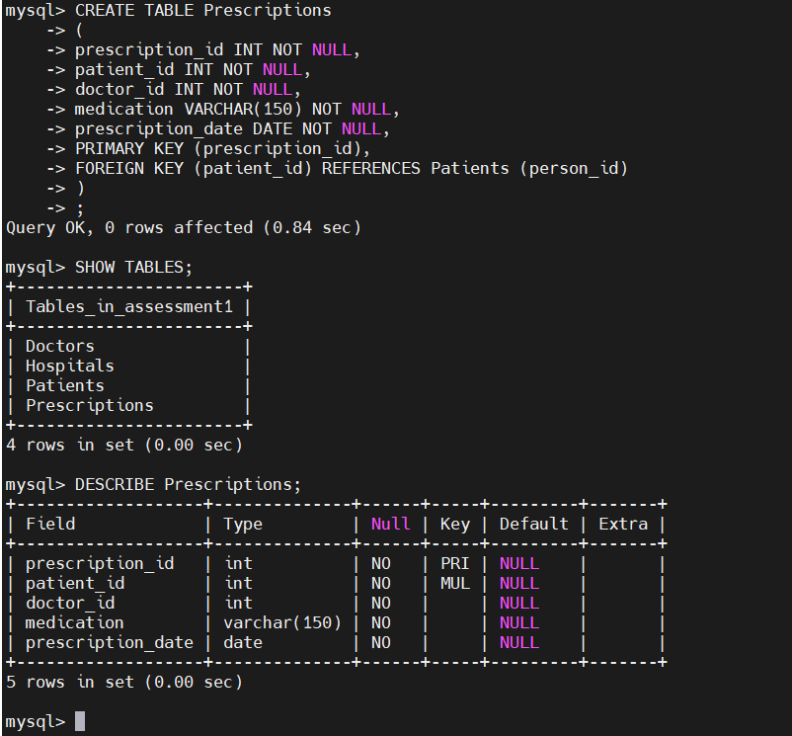
Not all data present in table shown below screenshot:
